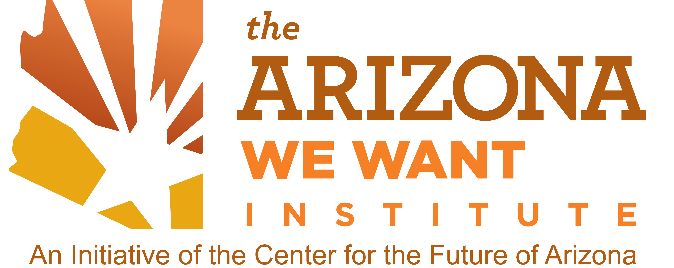

NEWS RELEASE

Media Contact: Debora Mitchell
602.989.3636
deb@deboramitchell.com

Center for the Future of Arizona Announces
2012 Gabe Zimmerman Public Service Award Winners

PHOENIX (July 24, 2012) -- David Byers, Doug Bartosh and Michael Hemesath have been named winners of the 2012 Gabe Zimmerman Public Service Awards, a statewide competition created to recognize non-elected public servants. Winners will be honored at the League of Arizona Cities and Towns Annual Meeting on Aug. 30.

Byers, director of the Administrative Office of the Courts for the Arizona Supreme Court, will receive the Leadership award. Bartosh, city manager of Cottonwood, will receive the Civic Engagement award. Hemesath, director of public works for the City of Sierra Vista, will receive the Innovation award.

The awards are named in honor of Gabrielle Giffords' director of community outreach who lost his life on Jan. 8, 2011 while serving the citizens of Arizona. "These exemplary public servants represent the spirit of service to the public by which Gabe Zimmerman lived his life," Dr. Lattie Coor, chairman and CEO of the Center for the Future of Arizona, said. "They represent the best of the more than 100,000 professional public servants working at all levels of Arizona government."

Nominees were judged on their achievements, such as how they've made a profound difference in improving service to the public, changed operations to better service the public, upheld the public interest with integrity and conviction, and their legacy contribution of lasting significance to Arizona citizens.

With support from the Zimmerman family, the 2012 Gabe Zimmerman Public Service Awards are sponsored by the Center for the Future of Arizona, the County Supervisors Association of Arizona, the Inter Tribal Council of Arizona, Inc., and the League of Arizona Cities and Towns.

About the Winners

David Byers has dedicated his entire career to public service and has served as director of the Administrative Office of the Courts for nearly 20 years. His position is like that of a CEO for the entire Arizona court system. He oversees a system that employs 10,000 people, operates in more than 200 locations and processes more than three million cases per year.
- more -
Page 2 of 3
Gabe Zimmerman Public Service Award Winners

The nomination submitted on Byers behalf states, "He is a thoughtful leader, who always strives to improve systems and programs that promote an independent judiciary. As a leader, Dave is bold, but thoughtful. No person has dedicated as much time, energy and commitment to the administration of justice as Dave Byers."

Byers has successfully kept Arizona on the forefront of modern court practices and has championed numerous ground-breaking programs that have sustained long after he turned over management. Among his many accomplishments is the Foster Care Review Board system that engages statewide citizen volunteers to review cases. Today, 515 citizens serve on 103 Review Boards. The program is recognized as a national model by the National Project of Juvenile and Family Court Judges and by the U.S. Department of Justice.

Doug Bartosh became city manager of Cottonwood nine years ago after a successful career as a police officer, including chief of police positions at Arizona State University, the City of Scottsdale and the City of Cottonwood. As city manager, he is the administrative head of the city with the responsibility for all city government affairs.

Bartosh's nomination highlights that he epitomizes the ideal servant-leader who is content to stay in the background, avoiding well-deserved accolades, while consistently rocking the world around him through his innovative and courageous deeds. It states that he is "a model of how to engage citizens in solutions to community problems."

As an example, Bartosh was instrumental in creating MATForce, a grass roots effort asking the community to be a part of designing solutions to substance abuse problems, which were driving the crime rate, destroying lives and consuming public services. The Yavapai County Substance Abuse Coalition emerged and today is a vibrant, active coalition recognized for its integrative approach to substance abuse issues. Recently, Yavapai County was selected by the Governor's Office as a pilot site to develop a model strategy to address drug abuse.

Michael Hemesath, who has spent his 29-year career with the City of Sierra Vista, originated the "PRIDE In Service" slogan, which stands for Pride, Respect, Integrity, Dependability and Excellence. He oversees the Public Works Department and is responsible for all public works functions, including supervision of 130 employees.

His nomination states that he consistently demonstrates superior technical skills and professionalism, but, more importantly, "has always placed the needs of the community first, continually looking for new and innovative ways to address growth." He's characterized as a director who is "always looking for a better way to do things."

Hemesath's innovative initiatives are reflective of a body of work over his career, not a single project. However, among his many successes, was a new wastewater treatment plant that resulted in the largest water mitigation project in the region, essential to helping Fort Huachuca.

- more -

Page 3 of 3
Gabe Zimmerman Public Service Award Winners
Through a chemical-free process, the plant utilizes aerators, microorganisms and wetlands to clean the water. Through connections with local birding organizations, a bird viewing platform was built adjacent to the wetlands, which allows groups to conduct weekend tours.

About The Center For The Future of Arizona

The Center for the Future of Arizona www.ArizonaFuture.org is an independent 501(c)(3) nonprofit organization. Its mission is to help Arizonans shape and define the future through an action-oriented agenda focused on contemporary issues and topics critical to the state. More than a think tank, the center is an independent “do tank” that combines public-policy research with collaborative partnerships and initiatives that will create new opportunities for all Arizonans.

About The Arizona We Want Institute

The Arizona We Want Institute is an initiative of the Center for the Future of Arizona. It is designed to implement a citizen's agenda based upon findings of the center's Gallup Arizona Poll. For more information about The Arizona We Want Institute, visit www.TheArizonaWeWant.org.

About League of Arizona Cities and Towns

The League of Arizona Cities and Towns is a voluntary association of all the 91 incorporated cities and towns in the state of Arizona. It provides policy and legislative advocacy, information and inquiry services, along with publications and educational programs to strengthen the quality and efficiency of municipal government. It was founded in 1937 to serve the interests of cities and towns and to preserve the principles of home rule and local determination.

About County Supervisors Association of Arizona (CSA)

For 30 years, the CSA has served as a forum for county officials to address important issues facing local constituents. The association provides a mechanism to share information among county officials and professional staff, and works to advance issues of county interest with the state and federal governments. Membership includes the 55 elected supervisors from Arizona’s 15 counties.

About Inter Tribal Council of Arizona, Inc.

In 1952, the elected leaders of nine Indian Tribes formed an association to provide members with a united voice. Today, 20 federally recognized Indian Tribes belong to the Council. Their mission is “…to be the voice of the member Tribes in bringing about Indian involvement and self-determination.”

###

