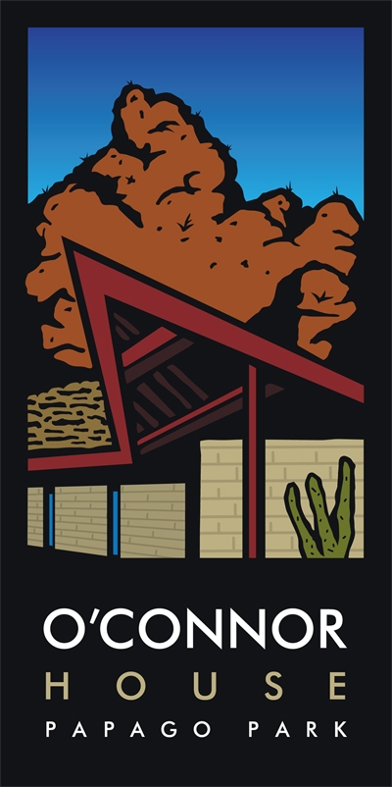
O’Connor House is a place where civil talk leads to civic action. Its vision is to create an Arizona where important policy decisions affecting our future are made through a process of civil discussion, critical analysis of facts, and informed participation of all citizens. The Centennial Voter Engagement Project is an initiative of the O’Connor House vision that specifically addresses the “informed participation of all citizens.” Without a fully informed electorate and greater voter participation in all elections (primaries in particular), much-needed policy changes are not likely to occur. Worse yet, our state will not be able to provide what Arizonans want and need to make our state competitive while offering economic and educational and opportunities for all residents.

Voter participation in Arizona ranks among the lowest in the nation. The 2010 Center for the Future of Arizona’s report titled The Arizona We Want found that:
Arizonans are not as well informed as people in other states
Arizona voter turnout declined in the 2008 Presidential election
Arizonans feel a growing disconnect with the leaders they elect to represent them

The statistics are frightening. 31% of eligible voters in Arizona are not registered. 42% of eligible voters did not vote in the 2008 Presidential election. 78% of eligible voters typically do not vote in primaries.

Registering and providing access for voters is merely the first phase of this important Project. Long-term goals include building on this statewide network of organizations, increasing civic education opportunities, and promoting civil discourse.

Get Involved
O’Connor House
Voter Engagement Project
Speak Out Arizona!
Capitalizing on the excitement of a presidential election year, O’Connor House and hundreds of other organizations have committed to promoting civic involvement and creating communities of active voters. The Project unites nonprofits, towns, counties, businesses and other civic-minded organizations, working together to
build non-partisan, thoughtful, and respectful approaches to tough issues facing our state. You can help!
- Become a Sector Partner. Sector partners are organizations that agree to partner with the project to promote statewide conversation about voting and civic engagement.
- Become a Voter Engagement Partner. Voter Engagement Partners are individuals who agree to form or participate in building teams of local citizens to implement the goals of the Project.

The Project

The Need

Think Ahead
Contact us with your ideas today
Voter.oconnorhouse@gmail.org
602-682-2019

speakoutaz.org

