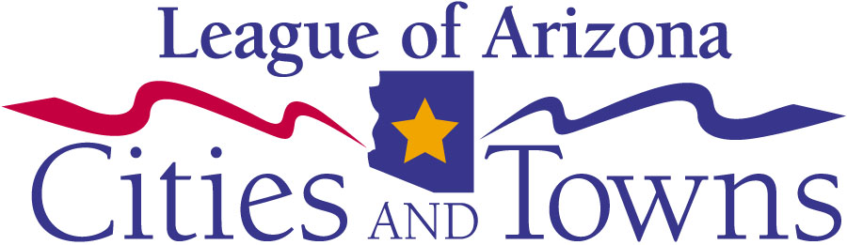

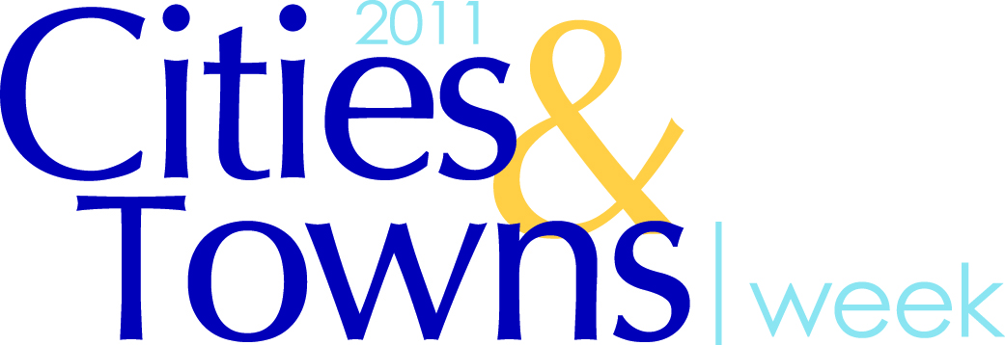

Resolution

Whereas; the citizens of <<insert city or town>> rely on local government to experience a high quality of life in our community; and

Whereas; local governments around the state of Arizona work 24 hours a day, seven days a week to deliver city services such as fire, police and emergency medical services to create safe communities; and

Whereas; the methods of funding these vital city services are not always clearly understood by citizens; and

Whereas; it is one of the responsibilities of city/town officials to ensure that legislators, media and citizens understand their local government through open and frequent communication using various avenues and means; and

Whereas; it is important to work to encourage this connection and inform citizens and state legislators of the importance of state shared revenues in order to preserve the excellent delivery of services that our citizens have come to expect in our city; and

Whereas; through education and awareness, citizens, community leaders and city staff can work together to ensure that services provided by <<insert city or town>> can remain exceptional elements of the quality of life of our community.

Now therefore be it resolved that the city of <<insert city or town>> joins with the League of Arizona Cities and Towns and fellow municipalities across the state of Arizona in declaring October 24-28, 2011, Arizona Cities & Towns Week.

