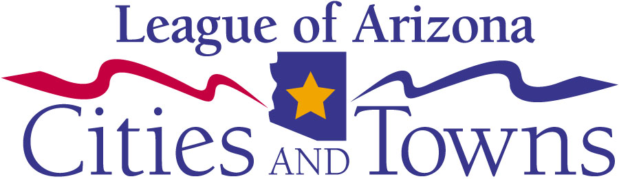
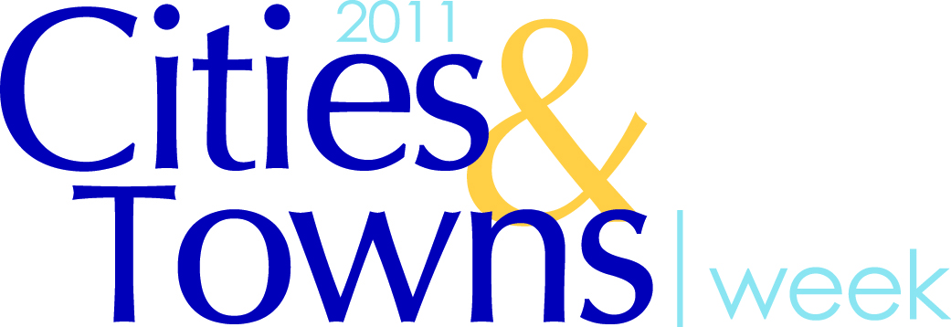
Insert Your City or

Town Logo Here

Media contact: Your Name

Title, City/Town
Phone Number
E-mail address

FOR IMMEDIATE RELEASE

<<YOUR CITY OR TOWN>> TO PARTICIPATE IN ARIZONA'S
10th ANNUAL CITIES & TOWNS WEEK

<<CITY/TOWN>>, Ariz. - (Month Day, 2011) <<insert Mayor's name>> today announced that << name of city/town>> will join municipalities across the state of Arizona and take part in the League of Arizona Cities & Towns' tenth annual Cities & Towns Week from October 24-28, 2011. The entire community of << name of city/town>> is encouraged to learn more this week about the services and programs that the <<city/town>> offers to improve the quality of life in our community.

"Our <<city/town>> works around the clock to provide vital services to make <<name of city/town>> a safe and exceptional place to live, work and play," said <<Mayor's name>>. "Participating in Cities & Towns Week offers our community an important opportunity to join together with cities and towns across the state to highlight local government's essential contribution to our citizen's daily lives."

<< Name of city/town >> will be offering <<insert a brief description of your event including date, time and location>> (E.g. meeting with legislative candidates, guided tours of the library or fire station, or community-wide cleanup to encourage community participation.)

Cities & Towns Week is set aside each year to provide citizens with important information about the services and programs provided by their city/town, and to introduce the employees that deliver them.

About << name of city/town >>
<<Insert brief description of your city or town or a boilerplate if your PIO has one>>
###

