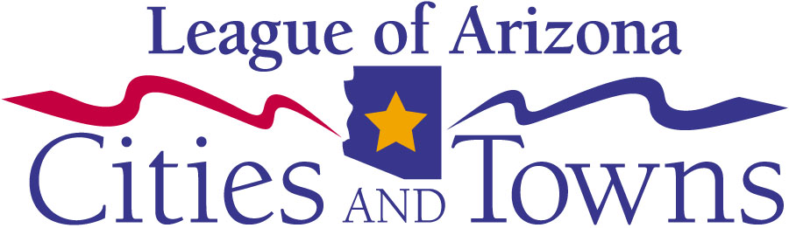


List of Suggested Events

Participating in Cities & Towns Week does not have to cost any money! In fact, nearly all of the events suggested here don’t cost anything to implement. Also, many cities choose to include the Cities & Towns Week message in an event that they already have scheduled.

Below is a list of suggested events your city or town may choose to host. If you have any ideas or suggestions, or have any questions about Cities & Towns Week, please do not hesitate to contact the League at 602-258-5786.

- Host a city or town hall open house and set up information tables for each department that is represented. Make sure that each table has a department representative available for citizen’s questions.
- Organize a group of citizens to volunteer to paint the home of an elderly member of the community.
- Invite the community to go on a tour of the Mayor’s Office. Invite kids to sit in the mayor’s chair.
- Have a recycling contest. See what organization, business or school can team up to collect the most recycling. Organize pickup and announce the winner in your community paper or newsletter. Ask a local restaurant or grocery store to donate a lunch for the winning team.
- Organize tours through departments that may be perceived as less interesting to illustrate to the community how vital they really are!
- Invite city and town workers i.e. police officers to talk about their jobs at your city or town hall or local school.
- Organize a community-wide cleanup of a public park.
- Coordinate a story hour at the library. Invite youth to attend and have a special guest reader: a firefighter, police officer, emergency medical services technician or even the mayor.
- Have guided tours of your library and highlight the programs the library offers. Serve donated refreshments.
- Plan a parade of city service departments. Fire trucks, police cars, the Bookmobile, little league teams, streets and water department workers and service trucks– all led by the mayor.
- Host an essay contest with local schools and announce the winner at a Cities & Towns Week program. A possible essay topic: “What would life be like for me and my family without city or town services?”
- Invite local schools to attend a lunch hosted by your city or town hall. Have a local grocery store donate sandwiches and soda. Have a firefighter and a police officer speak about safety in our schools.
- Work with your local school districts and coordinate a “Local Government Career Day.” Have the mayor, manager, councilmembers and city/town service worker to talk about their jobs with students.
- Arrange for your city or town hall to host a “Youth Mentoring Day” and have exceptional city or town workers shadowed to illustrate the impact that their jobs have on the community.

